GRADUATE ACADEMIC PROGRAM REVIEW

UNIVERSITY OF MARYLAND SCHOOL OF GRADUATE STUDIES

OVERVIEW AND PURPOSE

The Council of Graduate Schools notes that graduate program review has five general purposes: quality assurance, quality improvement, accountability, identification of strategies for improvement, and providing the institution with information for prioritization of resources. Reviews share certain key characteristics:

- Program review is evaluative, not just descriptive. It requires academic judgments about the quality of the program and the adequacy of its resources. It goes beyond assessment of minimum standards to subjective evaluations of quality by peers and recognized experts in the discipline or field.

- Forward-looking graduate program review aims to improve the program, not simply assess its current status. It makes specific recommendations for future changes, as part of the long-range plans of the institution, the department, and other coordinating units.

- Programs being reviewed are scrutinized on the bases of academic strengths and weaknesses, not on their ability to produce funds for the institution or generate development for the state. Finances and organizational issues are relevant, but only as they affect the quality of the academic program.

- Program review is an objective process. It asks graduate programs to engage in self-studies that assess, as objectively as possible, their own programs. External faculty from other institutions review the self-studies and make independent evaluations.

- Graduate program review is an independent process, distinct from any other review. Data collection and parts of the self-study may often serve a number of review purposes. However, to be effective, graduate program review must be a unique, identifiable process that stands on its own, draws its own set of conclusions, and directs its recommendations to the individuals with the power to improve graduate programs: the faculty and administrators of the institution.

- Program review results in action. Based on the reviewers’ comments and recommendations, as well as the program faculty’s response to the review report, the institution develops and agrees on a plan to implement the desired changes according to a specific timetable.

Incorporating these characteristics, a successful graduate program review answers the following questions:

- How well is the program advancing the state of the discipline or profession?
- How effective is its teaching and training of students?
- To what extent does the program meet the institution’s goals?
- How is it assessed by experts in the field?
- How well does it assess student outcomes and take action to improve based on the assessment data?

At UMB Graduate Program Review includes an internal self-study, an on-site review by an external site team, and a response by the program.

PROCEDURES

Periodic review of Graduate Programs is conducted under procedures established by the University System of Maryland (USM) and the Graduate Council. At UMB the review of existing academic programs includes both a self-study (internal review), an on-site external review and response by the program. It concludes with a summary follow-up report to USM and Graduate Council.

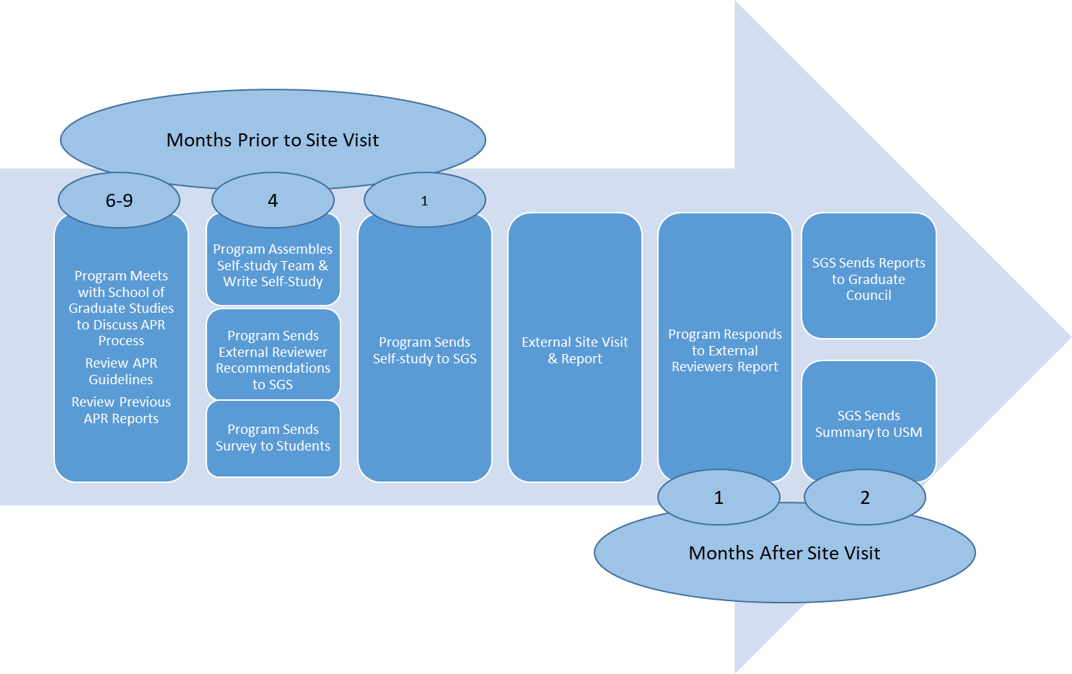

  - Schedule
As per USM policy all Post-Baccalaureate Certificate, MS, and PhD programs are scheduled for review on a seven year cycle. This schedule is subject to modification due to requirements of prior reviews or other exigencies. Modifications to the program review schedule must be approved by the Office of the Vice Chancellor for Academic Affairs USM.

Program reviews may occur any time during the academic year. It is the responsibility of the School of Graduate Studies to notify the Graduate Program Director (GPD) at least six months before a review is due. At that time, a tentative schedule will be developed.

Self-studies routinely require about four months to complete. The Dean of the School of Graduate Studies (Dean) should be provided the final documents at least a month before the scheduled external site visit to distribute to the external site team.

  - Self-Study
The Graduate Program Director (GPD) is responsible for the internal self-study and the self-study report. (See Graduate Program Review Self-Study Guidelines June 2020 for specific direction concerning the self-study.)

The complete self-study, including appendices, are due in the School of Graduate Studies four weeks before the scheduled external review team visit. The School of Graduate Studies will forward the self-study to the external reviewers. It is the responsibility of the program to provide the Dean of the professional school and other academic and administrative leaders within the School copies of the self-study as appropriate.

  - External Review Team
Usually external teams will usually be composed of two reviewers. Three-four months before the anticipated visit, the GPD will provide the School of Graduate Studies a list of 5-6 potential reviewers, including affiliation and reasons why the individuals will be appropriate reviewers for this program. Reviewers with conflicts of interest or perceived conflicts of interest should not be proposed. These categories may include: former UMB students, staff or faculty, close friends or collaborators of current program faculty.

The School of Graduate Studies will contact reviewers, make all arrangements for travel and hotel, process reimbursement, and receive the team’s report.

Site Visit –The Program, in consultation with the School of Graduate Studies, will construct the two day site visit itinerary and to provide logistical support, including access to computers, etc. The itinerary must include time with: faculty responsible for the program, including admissions/progression and curriculum; department chair; the school dean or designee; faculty teaching in the program and those responsible for significant research and/or training grants; and students. While some students may be selected to meet with the team, an open time for all students with the team must be available. A tour of program space and core facilities used by the program should be included if there is time.

The Dean of the School of Graduate Studies will meet with the team at the beginning of the site visit – usually for breakfast the first morning – and at the conclusion of the site visit to receive and discuss their preliminary report.

The School of Graduate Studies will pay for travel expenses, lodging, and meals according to state per diem. Program or department expenses will not be reimbursed by the School of Graduate Studies nor will any entertainment expenses for the team. The program is responsible for costs of preparation of the self-study.

  - External Reviewers Report
The final product from external reviewers is a written report that explicitly identifies program strengths and weaknesses and suggests actions that could improve the program’s national ranking. The team will provide the Dean of the School of Graduate Studies a written draft of the report, including key observations and recommendations, before they leave campus. The will provide the Dean of the School of Graduate Studies with the final report within a specified number of weeks. The School of Graduate Studies will distribute the final report to the program, Graduate Council, the dean of the professional school and other recipients.

  - Response to the External Reviewers Report
Within three weeks of receiving the report the program prepares a written response addressing reviewers’ recommendations and proposing plans for implementation of the recommendations or explanations as to why the recommendations should not be followed. This response is shared with the same individuals/groups who received the report.

  - Reporting to Board of Regents
A summary of the findings of the self-study, the external team, and the institutional response to the review are provided by the Vice President for Academic Affairs to the Graduate Council Program Review Committee, the USM Vice Chancellor for Academic Affairs, and the Education Policy committee of the USM Board of Regents.

  - Follow-Up to the Review
Graduate Council has established that programs may be asked for mid-term reports (usually three years following the review) in order to determine progress towards meeting team recommendations.

SELF-STUDY GUIDELINES

The following are guidelines to assist UMB Graduate Programs in conducting their self-study. The self-study should be presented in three volumes. Volume I, beginning with an executive summary, contains the self-study narrative or the report (See “Elements of the Self-Study” below.). Volume II should contain printed materials describing the program’s guidelines, procedures, any relevant School, Department, or Program strategic planning materials. Volume III is faculty curricula vitae. Volumes II and III can be linked on a program website.

The self-study process is most valuable to the program when all members of the program – junior and senior faculty, graduate students, postdoctoral fellows and administrators - are involved or represented in the self-study. A director of the self-study will be named by the program.

Whether or not they serve on the review committee, graduate students should participate in the program review process. They should be asked to complete confidential questionnaires where feasible, they should be interviewed individually and collectively by the external review committee, and they should have input into the self-study.

The Council of Graduate Schools describes the self-study, prepared by the faculty of the program as “descriptive, evaluative, and aspirational.” It provides basic information on the program, gives the faculty’s assessment of the program’s strengths and weaknesses, and presents the faculty’s vision for the program’s future.

  - Elements of the Self-Study
The information described below should be included in each self-study. Wherever possible, data should be provided for at least the previous five years.
- Program mission, organization and purpose: Provide a brief introduction to the program. Purpose of the program, contribution to the school and institution’s mission, departmental affiliations and program organization. Highlight any unique noteworthy policies or organizational structures, describe the relationship and interaction with any other graduate and professional programs.
- Program purpose: Describe the intellectual place in the discipline, national need for the program, and the program’s objectives (broad, general goals) and learning outcomes (specific, measurable results – e.g. faculty expectations for students – that the program seeks to achieve in order to meet its objectives.) Include a description of need for the programs (benefits to the institution/local area/state/world). Briefly describe local/national/international trends seen in the discipline and profession as relates to degrees and certificates as well as to research or application of skills and practice in your programs. Briefly discuss perspectives from industry and other partners related to the direction of field (the discipline as a whole or specific subfields) and the needs in the profession. How do you keep abreast of new developments and decide when/if/how to implement them?
- Program assessment plan: Recent assessment of program objectives and outcomes and the use of assessment findings for program improvement within the last five years.
- Program size: Number of graduate faculty, support staff, students, and degrees awarded in last five years by degree type.
- Faculty profile: Number and classification of graduate faculty (full/part-time, visiting, tenure/non-tenure track, adjunct); total number of faculty; procedures by which faculty are selected to affiliate with the graduate program; and average number of thesis and dissertation students for each faculty member. Discuss participation challenges particular to your program and your goals and efforts to address those. Are results, data, and trends in alignment with your goals?
- Faculty research and scholarly activity: Description of primary areas of faculty research and scholarship and external grants submitted and funded. How do these findings relate to your strategic vision for the next five years?
- Student profile: Admissions criteria (including Technical Standards); number of applied and admitted students; actual enrollments (pre- and post-candidacy for doctoral students); average standardized test scores and undergraduate grade-point averages of applying, admitted, and enrolled students; citizenship; average age, gender, ethnicity, citizenship, and part-time/full-time status. Discuss participation challenges particular to your programs or disciplines and your goals and efforts to address those. Are results, data, and trends in alignment with your goals?
- Student advising: When and how are student’s advisors chosen or appointed.
- Financial support for graduate students: Philosophy of support for students; amount of departmental, program, and institutional funding for students; types of support - stipends, teaching/research assistantships; tuition remission, scholarships, fellowships, and loans; and the selection process.
- Facilities: Space (classroom, research, office, student congregate space), laboratory and core facilities resources; library and computer resources.
- Curriculum: Strength and Quality, Including Related Communication and Supports for Student Learning: Degree requirements, relationships between the different levels of degree program, program structure, current courses, rotations, frequency of course offerings, use of online education and pass rates on preliminary (candidacy) and final oral exams; and how the curriculum reflects the current state of knowledge in the discipline and emerging subfields. Briefly describe each graduate degree/certificate program by degree level. You may begin with excerpts of text from the most current graduate catalog describing each degree program. For Program Review purposes, be sure to include field specialties/concentrations, online degree program options, joint and dual degree programs, graduate certificates available, etc. If you have significant non-degree enrollment programs. Do you have criteria for selecting, evaluating, mentoring, training, and compensating faculty to ensure quality on-campus, online, and hybrid instruction? If you offer online learning options, have online degree programs, and/or have courses offered on other campuses, are procedures in place to orient students to online and distance learning and to assess that learning outcomes and programs are comparable to those for main campus classroom programs? How do you, or do you plan to, know how your procedures are impacting student success? Are your efforts and results in alignment with your goals?

Include the handbook and checklist distributed to new students. Include a representative curriculum for a student at each level of the program from admission to graduation including milestones, seminars and rotations.
- Student productivity: Number of theses and dissertations for the last five years; sample dissertation and thesis quality; student publications, exhibitions, and professional presentations; degree completion rates; and average time to degree for each degree level.
- Programmatic climate: scholarly community, quality of student mentoring, spirit de corps, critical mass of faculty and students, and activities that promote among all students and faculty.
- Student Professional Development: Describe your graduate students’ career preparation and professional development. Include evidence of student participation in PD and mention any efforts to remove barriers to student participation. Are efforts and results in alignment with your goals? Reference any relevant data on PD services utilized or marketed in your department/programs. Do you announce these workshops/opportunities to your students? Do your students/faculty participate?
- Profile of graduates: Provide data (Number of graduates and types of job placements) on and discuss recent student and alumni continued contributions to the field or profession and other reported outputs that are indicators of program effectiveness. Append and reference any appropriate surveys and responses. Are the data and indicators of success in alignment with your goals?
- Future directions: List, describe, and/or discuss your goals for the next five years, detailing potential mid-point goals where possible. Describe as best you can specific steps/actions/resources needed to reach each goal. This may include plans for new faculty hires, new courses, new facilities, new or expanded research and curricular thrusts.
- Overall evaluation of program: Strengths, weaknesses, and national reputation.

In addition to the items included above, there may be specific questions, issues, or foci that the GPD, Department Chair, or Dean may want addressed in the self-study and/or by the external review team. Any additional program-specific elements should be identified before the self-study begins.

Assessment and Review of Graduate Programs: A Policy Statement. 2011. Washington, DC: Council of Graduate Schools. The New Academic Program Review Parts I &11. Ron Yanosky: Educational Advisory Board 2020.
Assessment and Review of Graduate Programs: A Policy Statement. 2011. Washington, DC: Council of Graduate Schools,.

