ARC-PA Consultant’s
Conference
April 2022

1

Welcome

© 2022 ARC-PA. ALL RIGHTS RESERVED.

2

Goals

Deepen attendee’s understanding of the ARC-PA accreditation process and the Accreditation Standards for Physician Assistant Education
5th edition.

Enhance attendee’s potential to guide their clients through a successful accreditation review.

© 2022 ARC-PA. ALL RIGHTS RESERVED.

3

Holding the Institution Responsible for its
PA Program

4

Frequency of Citations

Section A
Administration
30% (4th) 25% (5th )
Section B
Curriculum
36% (4th) 41%(5th)
Section C
Evaluation
30% (4th) 26%(5th)

Section D

Section A
Administration
30% (4th) 25% (5th )

Section B
Curriculum
36% (4th) 41%(5th)

Section C
Evaluation
30% (4th) 26%(5th)
Provisional
Accreditation
2%(4th) 2%(5th)
Section E
Accreditation
Maintenance
3% (4th) 5%(5th)

© 2021 ARC-PA. ALL RIGHTS RESERVED.
Section D
Provisional
Accreditation
2%(4th) 2%(5th)
Section E
Accreditation
Maintenance
3% (4th) 5%(5th)

5

Frequency of Citations
Section A: Administration 30%

Sponsorship
1%(4th ) 1% (5th)
Institution
Responsibilities
11% (4th) 14% (5th)
Institution
Resources
6% (4th) 2% (5th )

Program Faculty
7% (4th) 4%(5th)
Program Director
12%(4th) 17% (5th)
Medical Director
1%(4th) 2%(5th)

© 2021 ARC-PA. ALL RIGHTS RESERVED.

6

Most Cited
Institutional Responsibility Standards

A1.02 The sponsoring institution is responsible for:

a) supporting the planning by program faculty of curriculum design, course selection, and program assessment,

c) ensuring effective program leadership,

d) complying with ARC-PA accreditation Standards and policies,

© 2022 ARC-PA. ALL RIGHTS RESERVED.

7

A1.02 a, c & d
Evidence of Compliance

Application: Narrative describing institutional support

Site Visit: Evidence of active involvement of the institution in oversight and support for the program
◦ Discussions with program director, program faculty and senior institutional officials
◦ Minutes from meetings involving senior institutional officials
◦ Availability of supportive resources provided by the institution
◦ These individual may participate in the site visit (Data Manager, Director of Accreditation, etc)

At Commission Meeting: The Commission expects to see compliance with the standards and evidence of support documented by the site visit team

© 2022 ARC-PA. ALL RIGHTS RESERVED.

8

How a consultant can help

•Educate institution on their responsibility to ensure program success
oImmediate, frank, and direct conversations with senior institutional officials

© 2022 ARC-PA. ALL RIGHTS RESERVED.

9

How a consultant can help

•Educate institution and program on expectations related to accreditation
o Accreditation Manual
o Newsletters and communication from ARC-PA
o Workshops, conferences and presentations

© 2022 ARC-PA. ALL RIGHTS RESERVED.

10

How a consultant can help

•Guide program to fulfill those expectations on an ongoing basis
o Evaluate needs of the program through interviews and discussions
oProvide the knowledge, tools and resources

© 2022 ARC-PA. ALL RIGHTS RESERVED.

11

A1.02d Example of how a program demonstrated institutional support

The application described how the institution supports compliance through routine meetings between the PD, Dean and Provost to review action plans and compliance with ARC-PA standards. The narrative described the institution’s financial support and provision of resources to meet the standards. PD, faculty, and Provost have all attended ARC-PA training workshops supported by the institution. Updates of standards are requested by VPs and institutional staff to ensure compliance on the website and clinical site affiliations. The University Assessment of Learning Outcomes Committee reviews regular program assessment reports by the PA department and all other departments on campus and makes recommendations for curricular or other changes if needed based on self-assessment and external program review. This committee reports to the Provost and Graduate Council on actions needed and reviews compliance to be certain programs are meeting benchmarks.

The site visit team verified that the PD meets with the Dean on a weekly basis and the Provost approximately 2 times per month to discuss program issues including accreditation (verified through documentation of meeting notes reviewed on site). Discussion with the PD confirmed the strong institutional support to assure that the program has what it needs to meet accreditation standards. Discussion with senior institutional officials reflected that they were well versed in the accreditation standards and needs of the program.

© 2022 ARC-PA. ALL RIGHTS RESERVED.

12

What goes wrong? Example:

After receiving an adverse action from the ARC-PA due to repeated failure to submit an appropriate self-study report, the senior officials formed a Task Force to assist the program with its self-assessment process. The Task Force included the program faculty and two leaders from the institution, which began meeting weekly, approximately 6 weeks prior to submission of the modified self-study report for this visit.

The senior officials and the current faculty stated that if the program asked for assistance from the institution, it was provided to them, but it required asking first. The institution stated that by hiring the two PA consultants, it assumed that would help to fix the issues with self-assessment.

© 2022 ARC-PA. ALL RIGHTS RESERVED.

13

Program Director

W H O I S R E S P O N S I B L E F O R T H E P R O G R A M ?

© 2022 ARC-PA. ALL RIGHTS RESERVED.

14

A2.08 The program director must provide effective leadership and management by exhibiting:
a) responsiveness to issues related to personnel, b) strong communication skills, and
c) proactive problem solving

© 2021 ARC-PA. ALL RIGHTS RESERVED.

15

A2.09 The program director must be knowledgeable about and responsible for program:
a) program organization
b) program administration
c) fiscal management of the program
d) continuous programmatic review and analysis
e) program planning
f) program development
g) completion of ARC-PA required documents, and h) adherence to the Standards and ARC-PA policies

© 2021 ARC-PA. ALL RIGHTS RESERVED.

16

A1.02 The sponsoring institution is responsible for:
c) ensuring effective program leadership,

© 2022 ARC-PA. ALL RIGHTS RESERVED.

17

How a consultant can help

•Educate institution on how to properly assess the effectiveness of the program director
o Program Director evaluations
oPeriodic
oBased on accreditation standards oFeedback from different sources oConsider feedback from ARC-PA
oOngoing communication and feedback

© 2022 ARC-PA. ALL RIGHTS RESERVED.

18

A1.07 The sponsoring institution must provide the program with the human resources, including sufficient faculty, administrative and technical staff, necessary to operate the educational program, comply with the Standards, and fulfill obligations to matriculating and enrolled students.

© 2021 ARC-PA. ALL RIGHTS RESERVED.

19

How does a program determine sufficiency?

• Student/Faculty Ratio
• Comparable to similar programs

• Faculty/Staff Workload Assessment

• Ability to manage academic and administrative responsibilities

• Feedback
• Faculty
• Staff
• Students

© 2022 ARC-PA. ALL RIGHTS RESERVED.

20

A1.10

The sponsoring institution must support the program in:

a) securing clinical sites and preceptors sufficient in number to allow all students to meet the program’s learning outcomes for supervised clinical practice experiences and

b) ensuring all required rotations are located within the United
States.

© 2021 ARC-PA. ALL RIGHTS RESERVED.

21

Sufficient Clinical Sites & Preceptors

oTotals for each discipline must equal or exceed maximum class size.

oMust be active and have a written agreement to count

oEach clinical site must have an assigned clinical preceptor for each discipline.

oOn site documentation must reflect accepted number of students at each clinical site.

© 2022 ARC-PA. ALL RIGHTS RESERVED.

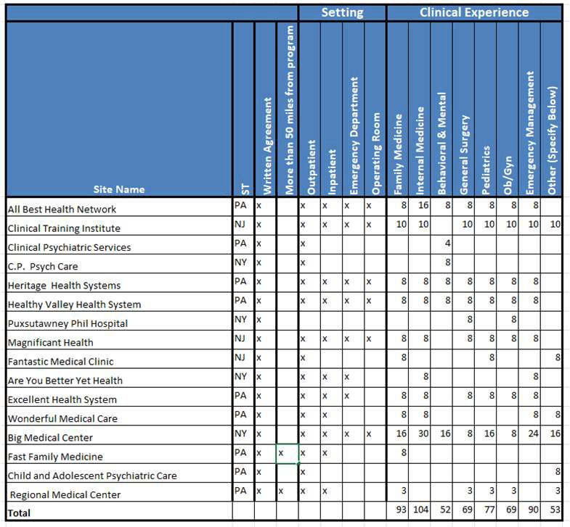22

A1.11

The sponsoring institution must support the program in demonstrating its commitment to student, faculty and staff diversity and inclusion by:

a) supporting the program in defining its goals for diversity and inclusion, b) supporting the program in implementing recruitment strategies,
c) supporting the program in implementing retention strategies,

d) making available resources which promote diversity and inclusion.

© 2021 ARC-PA. ALL RIGHTS RESERVED.

23

A2.16
Clarified Standard
March 2022

All instructional faculty actively serving as supervised clinical practice experience preceptors must hold a valid license to practice at the clinical site.

b) (rescinded effective 3.2022)
c) (moved to A2.17b, effective 3.2022)

© 2022 ARC-PA. ALL RIGHTS RESERVED.

24

A2.17
Clarified Standard
March 2022

In each location to which a student is assigned for didactic instruction or supervised clinical practice experiences, the program must:
a) inform the student which principal or instructional faculty member is designated by the program to assess and supervise the student's progress in achieving the learning outcomes it requires of students and how to contact this faculty member, and
b) orient all instructional faculty to specific learning outcomes it requires of students.

© 2022 ARC-PA. ALL RIGHTS RESERVED.

25

Frequency of Citations
Section A Administration 30% (4th) 25% (5th)

Instructional
Faculty
2%(4th) 0%(5th)
Admin Support
Staff
1%(4th) 0%(5th)
Operations & Policies
6%(4th) 0% (5th)

Fair practices &
admissions
37%(4th) 45%(5th)

Student Records
9% (4th) 9%(5th)

Faculty Records
3%(4th ) 0%(5th)

© 2021 ARC-PA. ALL RIGHTS RESERVED.

26

A3.13

The program must define, publish, consistently apply and make readily available to
prospective students, policies and procedures to include:

a) admission and enrollment practices that favor specified individuals or groups (if applicable),
b) admission requirements regarding prior education or work experience, c) practices for awarding or granting advanced placement,
d) any required academic standards for enrollment and e) any required technical standards for enrollment.

© 2022 ARC-PA. ALL RIGHTS RESERVED.

27

A3.14

The program must make student admission decisions in accordance with clearly defined and published practices of the institution and program.

Application will include forms used to screen applications and select candidates for class positions.

© 2022 ARC-PA. ALL RIGHTS RESERVED.

28

A3.13a & A3.14
Demonstrating Compliance

•Identify any characteristic that reflects a preference in the admissions process
• 3+2 or 4+2 candidates who receive their undergraduate degree from the same sponsoring institution or from an affiliated institution
• “Regional” geographic preference
• “Underrepresented” groups
• Be clear about what the program means by the term underrepresented-for example: first generation, low income, minorities, disabled status, etc.
• “Military service”
• Clarify if it includes veteran, active, and/or reserves.
• “Significant” healthcare experience or community service
• Indicate the number of hours or type of experience the program deems as “significant”.

•Distinguish if the preference is given for interview only or accepted admission.

© 2022 ARC-PA. ALL RIGHTS RESERVED.

29

A3.13a & A3.14
Demonstrating Compliance

•Information must be consistent
• Published policies/procedures
• Application
• Internal admission documents (screening forms, interview forms, scoring rubrics, etc)
• Student admission records

• The program is not required to publish its internal scoring system; however, published preferences should reflect those qualities that are assigned additional points on admission rubrics.

© 2022 ARC-PA. ALL RIGHTS RESERVED.

30

Questions & Open Discussion

A Standards

© 2022 ARC-PA. ALL RIGHTS RESERVED.

31

© 2022 ARC-PA. ALL RIGHTS RESERVED.

32

Competencies, Learning Outcomes & Instructional Objectives, Oh My!

33

B1.01

The curriculum must:
a) be consistent with the mission and goals of the program,
b) be consistent with program competencies,

© 2021 ARC-PA. ALL RIGHTS RESERVED.

34

Program
Competencies
Required for PA Practice

What does the program expect its students to achieve by the time they graduate?

Must address:
• Knowledge
• Interpersonal Skills
• Clinical & Technical Skills
• Professional Behaviors
• Clinical Reasoning
• Problem-Solving

© 2021 ARC-PA. ALL RIGHTS RESERVED.

35

B1.03
For each didactic and clinical course (including required and elective rotations), the program must define and publish learning outcomes and instructional objectives, in measurable terms that can be assessed, and that guide student
acquisition of required competencies.

© 2021 ARC-PA. ALL RIGHTS RESERVED.

36

What are Learning
Outcomes?

T H E M E D I C A L K N O W L E D G E , I N T E R P E R S O N A L , C L I N I C A L A N D T E C H N I C A L S K I L L S , P R O F E S S I O N A L B E H AV I O R S , A N D C L I N I C A L R E A S O N I N G A N D P R O B L E M - S O LV I N G A B I L I T I E S T H AT H A V E B E E N AT TA I N E D AT T H E C O M P L E T I O N O F A C U R R I C U L A R C O M P O N E N T,
C O U R S E O R P R O G R A M .

© 2021 ARC-PA. ALL RIGHTS RESERVED.

37

Preparation for Entry into Clinical Practice

Learning outcomes are designed to prepare the student for the clinical practice of medicine as a new graduate (guides student towards achieving program competencies)

Learning outcomes are designed to prepare the student for the clinical practice of medicine as a new graduate (guides student towards achieving program competencies)

When defining program learning outcomes, programs must determine the level of competency they expect their students to achieve

Level of competence that prepares the student to enter

Not always mastery or even proficiency
current and evolving clinical practice as a newly practicing
PA

© 2021 ARC-PA. ALL RIGHTS RESERVED.

When defining program learning outcomes, programs must determine the level of competency they expect their students to achieve

38

Competencies Required for PA Practice

Learning Outcomes

*Requirements for Anatomy Course

*Requirements for Clinical Medicine Course
*Requirements for Pharmacology Course
Each course has separate learning outcomes

What is required for a student to successfully complete a course?

* Must address:
• Knowledge
• Interpersonal Skills
• Clinical & Technical Skills
• Professional Behaviors
• Clinical Reasoning
• Problem-Solving

© 2021 ARC-PA. ALL RIGHTS RESERVED.

39

Competencies Required for PA Practice

Learning Outcomes

*Requirements for Anatomy Course
*Requirements for Clinical Medicine Course
*Requirements for Pharmacology Course
Each course has separate learning outcomes

Instructional Objectives
Instructional Objectives for Head & Neck
Instructional Objectives for Upper Ext.

What is required for a student to successfully complete a unit of instruction?

• Specific
• Observable
• Measurable
• Provide the detailed steps need to achieve the desired learning outcomes

© 2021 ARC-PA. ALL RIGHTS RESERVED.

40

Competency
Apply principles of basic and clinical science, including anatomy, physiology, pathophysiology, and genetics to identify, diagnose, and provide patient centered care to healthy and ill patients.

Learning Outcomes for
Women’s Health Course
Demonstrate the ability to obtain a complete and accurate medical history and conduct a physical examination on a patient presenting for prenatal care.

Demonstrate proficiency in performing the following skills: pap smears, cervical culture, IUD removal.
Provide clear and comprehensive counseling to patients regarding their diagnosis, treatment and prognosis

Instructional Objectives for Women’s Health Course
Perform a physical examination on a patient for a pre- natal visit.
Take a prenatal history that includes assessment of risk factors.

Accurately measure fundal height and assess fetal heart tones.

List the items that should be included in a prenatal social history.

© 2021 ARC-PA. ALL RIGHTS RESERVED.

41

Helping Programs Understand the
B3 & B4 Standards

42

Frequency of Citations
B. Curriculum & Instruction 37% (4th ) 41%(5th)

Curriculum
13% (4th)
0.4%(5th)
Clinical Prep
Sciences
13%(4th) 30%(5th)

Supervised Clinical
Practice
74%(4th) 35%(5th)
Student
Assessment
12%(4th) 34%(5th)

© 2021 ARC-PA. ALL RIGHTS RESERVED.

43

B3.03

Supervised clinical practice experiences must enable all students to meet the program’s learning outcomes:

a) for preventive, emergent, acute, and chronic patient encounters,
b) across the life span, to include infants, children, adolescents, adults, and the elderly
c) for women’s health (to include prenatal and gynecologic care), d) for conditions requiring surgical management, including pre-
operative, intra-operative, post-operative care, and
e) for behavioral and mental health conditions.

© 2021 ARC-PA. ALL RIGHTS RESERVED.

44

B4.01

The program must conduct frequent, objective and documented evaluations of student performance in meeting the program’s learning outcomes and instructional objectives for both didactic and supervised clinical practice experience components. The evaluations must

a) align with what is expected and taught

b) allow the program to identify and address any student deficiencies in a timely manner

© 2021 ARC-PA. ALL RIGHTS RESERVED.

45

How does a program know each student has achieved the learning outcomes?

The length of courses/rotations, the number of patient encounters or experiences is not the key.

Assessment is the key.

Students must be able to demonstrate they can do what is expected of them after having had the experiences.

© 2021 ARC-PA. ALL RIGHTS RESERVED.

46

Competencies Required for PA Practice

Learning Outcomes

Requirements for
Anatomy Course
Requirement
Clinical Medi
s for *Abilities for cine Pharmacology
Course
Course

Assessment
Each course has separate learning outcomes

Instructional
Objectives

Instructional Objectives for Head & Neck

Instructional Objectives for Upper Ext.

Assessment

Assess instructional objectives to ensure students working towards achieving learning outcomes.

Assess learning outcomes to ensure students have achieved those abilities required to successfully complete the course.

© 2021 ARC-PA. ALL RIGHTS RESERVED.

47

Evidence of Compliance

Evaluation methods measure student performance in relation to the learning outcomes
and instructional objectives.

◦ Student assessment includes more than PANCE style questions.

◦ A variety of evaluation methods are used
◦ appropriate to what is expected and what is being measured.

◦ Evaluation methods use and document the judgment of skilled educators (program and instructional faculty) concerning student performance of required skills, behaviors and abilities.

© 2021 ARC-PA. ALL RIGHTS RESERVED.

48

Learning Outcomes for General Surgery
Pre-operative
• Demonstrate knowledge and understanding of common general surgeries including but not limited to: hernias, cholecystectomy, thyroidectomies, Nissen fundoplications, and small bowel resections.
• Communicates with patients, family and staff with respect, dignity and compassion
• Thoroughly and appropriately execute a pre-operative admitting history and physical exam.
• Participate as part of an interprofessional team providing patient-centered care as part of the surgical and medical management team caring for the surgical patient.
• Manage the pre-operative care of patients with common chronic medical problems such as hypertension and
diabetes. Intra-operative
• Demonstrate knowledge of the approach to common general surgeries including but not limited to: hernias,
cholecystectomy, thyroidectomies, Nissen fundoplications, and small bowel resections
• Communicates effectively with the surgical team.
• Demonstrate correct sterile technique.
• Perform suturing and or stapling including, interrupted sutures, running subcutaneous sutures, and or subcuticular sutures.
• Participate as part of an interprofessional team providing patient-centered care as part of the surgical and
medical management team caring for the surgical patient.
• Demonstrate knowledge of the medical management of common intra-operative complications such as severe blood loss, changes in blood pressure, and cardiac arrythmias.

© 2022 ARC-PA. ALL RIGHTS RESERVED.

49

Learning Outcomes for General Surgery
Post-operative
• Demonstrate knowledge and understanding of the post-operative care for general surgeries including but not limited to: hernias, cholecystectomy, thyroidectomies, Nissen fundoplications, and small bowel resections.
• Communicates with patients, family and staff with respect, dignity and compassion
• Demonstrate appropriate wound care technique and suture removal.
• Participate as part of an interprofessional team providing patient-centered care as part of the surgical and medical management team caring for the surgical patient.
• Manage post-operative patients, addressing wound care and wound management.
• Assess the patient for post-operative complications and makes appropriate decisions in their management

© 2022 ARC-PA. ALL RIGHTS RESERVED.

50

Sample Preceptor Evaluation

© 2022 ARC-PA. ALL RIGHTS RESERVED.

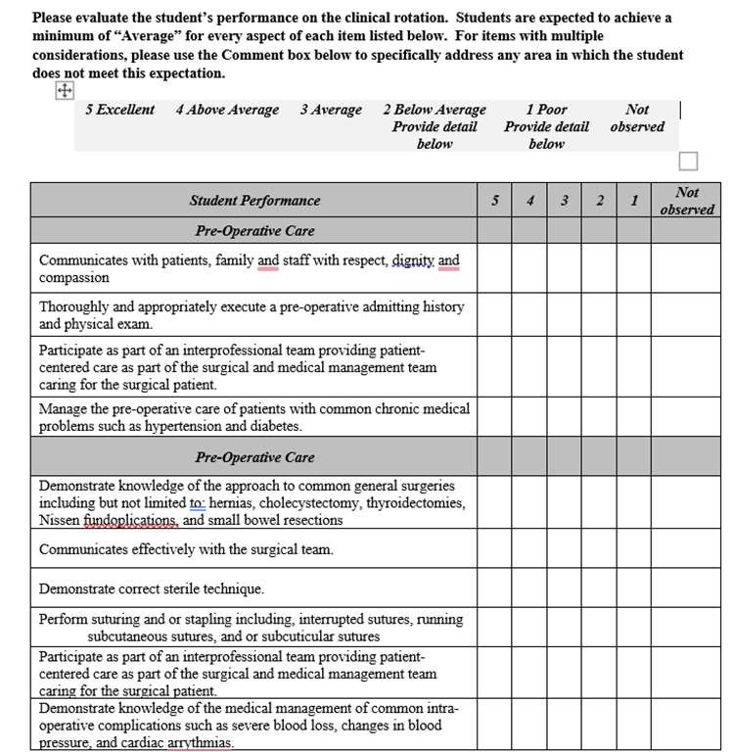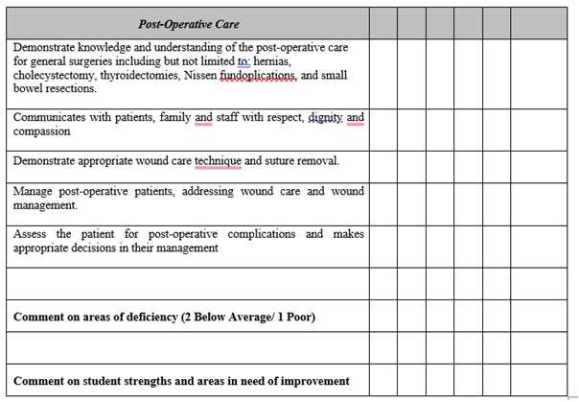51

How a consultant can help

Assist programs in defining expectations for students
◦ Competencies vs. Learning Outcomes vs. Instructional Objectives linked to the program’s mission and goals (B1.01a & b)

Assist program in understanding that student assessment must link instructional objectives, learning outcomes & competencies to student assessment
◦ Applies to both the didactic and clinical components of the curriculum.
◦ B3 standards frequently refer to student learning outcomes to assess student, clinical site and preceptors.
◦ Must be clear reflection of assessment of learning outcomes in student evaluation forms

Plan to address students who do not meet expectations

© 2022 ARC-PA. ALL RIGHTS RESERVED.

52

Questions & Open Discussion

B Standards

© 2022 ARC-PA. ALL RIGHTS RESERVED.

53

© 2022 ARC-PA. ALL RIGHTS RESERVED.

54

Ongoing Program Self-Assessment

55

Frequency of Citations
C. Evaluation

29% (4th) 26% (5th)

© 2022 ARC-PA. ALL RIGHTS RESERVED.

56

Process
C1.01 The program must define its ongoing self- assessment process that is designed to document program effectiveness and foster program improvement. At a minimum, the process must address:

a) administrative aspects of the program and institutional resources,

b) effectiveness of the didactic curriculum, c) effectiveness of the clinical curriculum,
d) preparation of graduates to achieve program defined competencies,

e) PANCE performance,
f) sufficiency and effectiveness of principal and
instructional faculty and staff, and
g) successes in meeting the program’s goals.

© 2022 ARC-PA. ALL RIGHTS RESERVED

57

C1.01
The Application: Appendix 14 SSR

Provide Narrative describing the program’s established, formal, continuous self-assessment process utilized throughout the academic year and in all phases of the program.

The process described should be consistent with the data sources and timing of data collection and analysis listed in the Timeline for Data Gathering and Analysis TEMPLATE Appendix 14A.

© 2022 ARC-PA. ALL RIGHTS RESERVED

58

What is expected for C1.01

Program must describe its self-assessment process

Include data sources used Quantitative and qualitative

Address administrative functions* and outcomes as well as the curriculum

*Such as those addressed in the A section of the Standards: institutional sponsorship, resources
(financial, human, physical and technology), policies/procedures, and student services.

Appendix 14A supports the narrative

© 2022 ARC-PA. ALL RIGHTS RESERVED

59

Implementation
C1.02 The program must implement its ongoing self-assessment process by:
a) conducting data collection,
b) performing critical analysis of data, and

c) applying the results leading to conclusions that identify:
i. program strengths,

ii. program areas in need of improvement,
iii. action plans.

 Described in response to C1.01 a-g.

 Verified by discussion with site visitors at the time of the site visit

© 2022 ARC-PA. ALL RIGHTS RESERVED

60

C1.03 The program must prepare a self-study report as part of the application for accreditation that accurately and succinctly documents the process, application and results of ongoing program self-assessment. The report must follow the guidelines provided by the ARC-PA.
Documentation

© 2022 ARC-PA. ALL RIGHTS RESERVED

61

The SSR

Used to verify that the program uses its ongoing self-assessment process to validate program effectiveness and foster program improvement.

Demonstrates how interpretations and conclusions were based on data collected and displayed

Documents analysis in a clear, coherent, succinct narrative that shows
trends and relationships used to arrive at the conclusions and plans.

© 2022 ARC-PA. ALL RIGHTS RESERVED

62

4 Elements of Analysis

Data Collection

Analysis of data

Application of results and development of conclusions

Development of action plans

© 2022 ARC-PA. ALL RIGHTS RESERVED

63

What To Assess? What Data To Collect?

Use the Standards….at a minimum!

Topic areas are included in the Standards C1.01

Programs should collect data needed to review the quality and effectiveness of the program.

Address important questions.
◦ Determine questions to be asked as part of process
◦ Collect data to answer questions

© 2022 ARC-PA. ALL RIGHTS RESERVED

64

Data must be collected and compiled over time

Issues about
Data
Collection and
Reporting

SSR requires 3-4 years of data

When incorporating relevant data from other areas (focus groups, PANCE system/task scores, etc.) append aggregate summaries of the data referred to in the narrative.

When incorporating relevant data from other appendices, (e.g., PANCE pass rates) provide specific reference to the other appendices.

© 2022 ARC-PA. ALL RIGHTS RESERVED

65

Issues about
Data
Collection and
Reporting
Where data collection tools employ scales, state the scale used and provide definitions for each of the available scores.

In general, use terminology from the Standards, upon which the SSR requirements are based, referring to the Glossary as needed.

Where data collection tools employ scales, state the scale used and provide definitions for each of the available scores.

Where called for, explicitly state benchmarks and explain the rationale for choosing that particular level of benchmark.

Where called for, explicitly state benchmarks and explain the rationale for choosing that particular level of benchmark.

In general, use terminology from the Standards, upon which the SSR requirements are based, referring to the Glossary as needed.

© 2022 ARC-PA. ALL RIGHTS RESERVED

66

Benchmarks

A method to measure outcomes to determine that the program is performing effectively

• Often used to identify areas for improvement
• Also used to identify strengths

Identifies the program’s minimum threshold for each assessment tool

Needs to be program specific

• External data (university benchmarks, PAEA data) may be used but program needs to account for its individual mission, needs and goals.

© 2022 ARC-PA. ALL RIGHTS RESERVED

67

Establish benchmarks for performance based on expected program outcomes

Internal and external evidence used to establish minimum benchmarks

Some programs establish benchmarks with multiple measures; for example, mean scores, downward trends, and abrupt changes of more than a specified amount.
Benchmarks

Internal evidence could include mean scores, trends over time, and/or correlation to other dimensions of program/student outcomes.

External evidence can include national data and/or institutional data.

© 2022 ARC-PA. ALL RIGHTS RESERVED

68

Analysis

“A study of compiled or tabulated data interpreting correlations and trends with the subsequent understanding and conclusions used to validate current practices or make changes as needed for program improvement.” (ARC-PA 5th Edition Standards Glossary)

© 2022 ARC-PA. ALL RIGHTS RESERVED

69

Analysis: What it is

Process that examines performance standards and relationships between areas of
the program

Benchmark Process to examine “trends over
• How does your data “measure up” to the Process to identify correlations time”
program’s defined benchmark for or cause and effect relationships
performance expectations? • Stable, increasing, decreasing
Conclusions are a logical outcome of analysis based on the data presented.

Action plans are clearly linked to those conclusions
© 2022 ARC-PA. ALL RIGHTS RESERVED
70

Analysis: What it isn’t

A restatement of the process of data collection

A reiteration of the raw data

A discussion about each data point, rather than examination of aggregate data

A presentation of data in isolation from other aspects of the program

A process that requires advanced (inferential) statistical computations

© 2022 ARC-PA. ALL RIGHTS RESERVED

71

Analysis: Quantitative Data

◦ Aggregate data compared to program-determined benchmark
◦ For cohort, examine patterns across multiple cohorts to identify trends
◦ Data correlation:
◦ Examination of qualitative data (themes or other benchmarks) along with quantitative data
◦ Examination of other data: for course evaluations this might include student evaluations of instructors, preceptor evaluations of student preparedness, preceptor evaluations of student performance, OSCE performance as part of summative exam, and graduate data

© 2022 ARC-PA. ALL RIGHTS RESERVED

72

Analysis: Qualitative data

•Summarize (analyze) the raw data and see what meets your benchmark – either positive or negative
• Don’t collect data and not use it or just make a comment in narrative such as
“students liked the course”

•Determine benchmark: maybe 3 comments for a “theme” or 10% (Class of 30)

•Examine for any comments of an "egregious nature” where even a single comment may prompt further evaluation

© 2022 ARC-PA. ALL RIGHTS RESERVED 73

73

Analysis

Questions to ask next….
•How does your data “measure up” to the program’s defined benchmark?

•Is it enough to say it meets benchmark?
• No, that is the starting point

•Can identify areas near or at the benchmark, but also examine areas performing well (“areas in need of improvement vs strengths”)

•For example, what is different between the three lowest performing courses and the three highest performing courses?
• This is where the more detailed course evaluation data can be examined to see what the differences are
• Which questions on the survey were low scoring?
• Was there a question about clarity of instructional objectives?

•Process to identity correlations or cause and effect relationships
• Examine your qualitative data in conjunction with your quantitative data

© 2022 ARC-PA. ALL RIGHTS RESERVED

74

Strengths

Use the table to list the strengths of the program identified as a result of the data analysis and conclusions documented in this appendix.

Outcomes of analysis described in the appendix that indicate the program is meeting or exceeding its benchmarks or goals

All strengths listed in the template should be supported by data analysis within the SSR.

© 2022 ARC-PA. ALL RIGHTS RESERVED

75

Modifications

Use the table to list modifications that occurred as a result of the program’s ongoing self-assessment process described in this appendix.

Omit modifications that are routine updates and not part of the self- assessment process

All modifications in the template should be supported by data analysis within the SSR.

© 2022 ARC-PA. ALL RIGHTS RESERVED

76

Areas in Need of Improvement

As a result of the data analysis and conclusions identified in this appendix, list the areas in need of improvement and plans for addressing these areas as identified by the program’s process of ongoing self-assessment.

If an area of improvement has been completed, list in the Modifications Table

Plans for addressing needed improvements address the conclusions drawn from analysis of trends and relationships documented in the SSR. .

© 2022 ARC-PA. ALL RIGHTS RESERVED

77

Case Study

78

© 2022 ARC-PA. ALL RIGHTS RESERVED.

79

Questions & Open Discussion

C Standards

© 2022 ARC-PA. ALL RIGHTS RESERVED.

80

Considerations for Emerging Programs

© 2022 ARC-PA. ALL RIGHTS RESERVED.

81

How a consultant can help

•Bring valuable knowledge and guidance throughout the process

•Help institutional officials and program director understand accreditation standards
• Ensure institutional officials understand their role in supporting the program

•Guide programs through the development of their curriculum and self-assessment process

•Consultants DO NOT substitute for institution/program responsibility for development and planning of program.

© 2022 ARC-PA. ALL RIGHTS RESERVED.

82

D1.01

Based on the qualifications outlined in the Standards, the program must have:

a) A 1.0 FTE program director hired by the institution on a permanent basis at least 15 months prior to the date of the scheduled site visit. If the person holding the position of program director changes in the 15 months prior to the date of the scheduled site visit, the program may be removed from the commission agenda.
b) A medical director appointed by the institution on a permanent basis at least
15 months prior to the date of the scheduled site visit.
c) 2.0 FTE PA-C principal faculty and 1.0 FTE support staff hired by the institution on a permanent basis at least 9 months prior to the date of the scheduled site visit.
d) A chief administrative officer or designee assigned to be responsible for the development of the program.

© 2021 ARC-PA. ALL RIGHTS RESERVED.

83

D1.02

The developing program must publish and make readily available
to everyone who requests information, applies or plans to enroll:

a) its ARC-PA applicant status as provided to the program by the
ARC-PA

b) that the program is not yet accredited, and

c) the implications of non-accreditation by the ARC-PA

© 2021 ARC-PA. ALL RIGHTS RESERVED.

84

Published Accreditation Information

•May expand with details and nuances of the proposed program

•Avoid language that implies accreditation is eminent, anticipated, planned to be received, or expected

•Statement that the program will not commence in the event that provisional accreditation is not received is required

•Include implications of non-accreditation

© 2021 ARC-PA. ALL RIGHTS RESERVED.

85

D1.03

Prior to the ARC-PA provisional comprehensive evaluation site visit, the program must have a complete and institution approved curriculum and have established evaluation methods for all didactic and clinical components of the program.

© 2021 ARC-PA. ALL RIGHTS RESERVED.

86

D1.05

The program must have signed agreements from prospective clinical sites participating in the supervised clinical practice experiences sufficient in number to meet the needs of the maximum class size.

© 2021 ARC-PA. ALL RIGHTS RESERVED.

87

Clinical Sites

For initial provisional application, program must have sites and agreements sufficient for the maximum class size at the time of the site visit.
• Signed agreements
• Documentation verifying number of students per rotation/per year

• Signed agreements
• Documentation verifying number of students per rotation/per year

Does the program’s SCPEs span greater than 12 months?

• How will the program handle scheduling the overlap of 2 clinical classes?
• How will program assure sufficient sites to accommodate ALL students during the overlap.

• How will the program handle scheduling the overlap of 2 clinical classes?
• How will program assure sufficient sites to accommodate ALL students during the overlap.

© 2021 ARC-PA. ALL RIGHTS RESERVED.

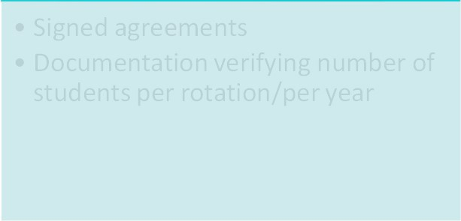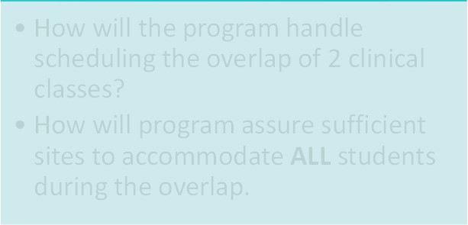88

Helping your program prepare for its site visit

© 2022 ARC-PA. ALL RIGHTS RESERVED.

89

Purpose of the Visit

To verify, validate and clarify the information supplied by the program in the application and self-study report.

It is the program’s responsibility to provide evidence in support of compliance.

© 2022 ARC-PA. ALL RIGHTS RESERVED

90

Submitting the Application

The application and supporting materials must be submitted on or before the deadline identified by the ARC-PA.
The application must include all appendices as required and be completed according to the instructions provided.

© 2022 ARC-PA. ALL RIGHTS RESERVED

The application and supporting materials must be submitted on or before the deadline identified by the ARC-PA.

The application must include all appendices as required and be completed according to the instructions provided.

91

Incomplete Applications

© 2022 ARC-PA. ALL RIGHTS RESERVED.

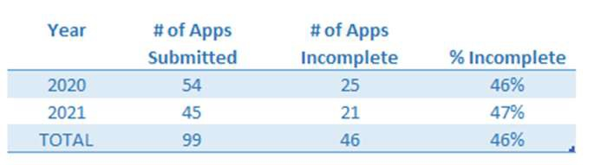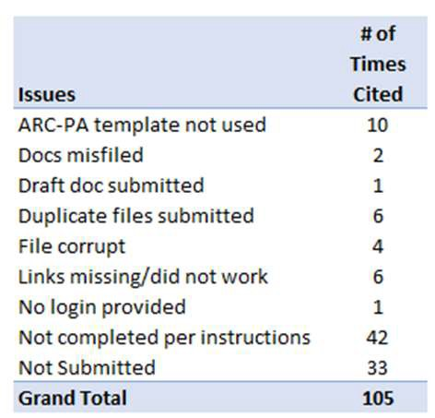92

Submitting the Application

Failure to complete all components of the application exactly as instructed and/or failure to submit a complete application may result in one or more of the following actions:

▪ Removal of the program from the current ARC-PA agenda
▪ Requirement for application resubmission
▪ Placement of the program on administrative probation
▪ Reconsideration of the program’s current accreditation status
▪ Forfeiture of all previously paid accreditation fees

© 2022 ARC-PA. ALL RIGHTS RESERVED

93

Application of Record

The application submitted by the program to the ARC- PA office is considered the program's application of record.

It is one component of the official program record used by the commission throughout the accreditation review process.

© 2022 ARC-PA. ALL RIGHTS RESERVED

94

Preparing for the Visit

Application includes list of materials to have available

Review materials about the site visit on the ARC-PA website

Contact the ARC-PA with questions

© 2022 ARC-PA. ALL RIGHTS RESERVED

95

Guidelines to Organize Documents
Electronically available at least three business days prior

Include overall “Table of Contents”

Documents organized by standard

Include folders with other required documents

Include empty folder

© 2022 ARC-PA. ALL RIGHTS RESERVED

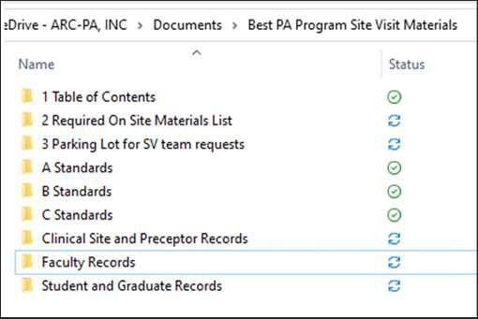96

How a consultant can help

•Bring valuable knowledge and guidance throughout the process
•Review the program’s documents to make everything is in order and is easy to find.

•Ensure that program personnel review the site visit schedule and understand expectations of interviews

•Help program prepare by facilitating/organizing a mock site visit

•Sit down with the groups that are going to be interviewed to help them understand what types of questions will be asked.

•Complete a mock site visit with program personnel

•Make sure program is familiar with site visit resources available on ARC-PA website appropriate for the type of visit

© 2022 ARC-PA. ALL RIGHTS RESERVED.

97

Observations vs. Citations

OBSERVATIONS

• Made by site visit team

• Based on information provided in application and at site visit

• Identifies standards in which the:
• Site visit team was unable to validate information
• Program was unable to demonstrate compliance

• Programs response is optional and reviewed by the Commission
CITATIONS

• Issued by the Commission

• Based on information provided in application, site visit worksheet and response to observations

• Identifies areas in which the program was judged not in compliance with the Standards

• Program response is not optional
• The ARC-PA sends programs a Microsoft Word template to complete and return

© 2022 ARC-PA. ALL RIGHTS RESERVED.

98

Questions & Open Discussion

© 2022 ARC-PA. ALL RIGHTS RESERVED.

99

Thank you

Please complete our post conference evaluation!

Email us if you have questions!
accreditationservices@arc-pa.org www.arc-pa.org
770-476-1224

© 2022 ARC-PA. ALL RIGHTS RESERVED.

100

