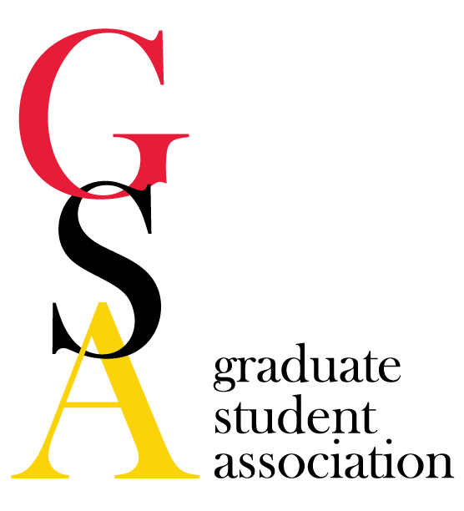
- GSA Meeting Agenda
Date: November 02, 2016
- Welcome/Call to order: 5:05pm
Amanda Labuza Quinton Banks Sarah Rudzinskas
Alyssa Grogan Kim Filcek Wan-wen Liao
Ramon Martinez Kendra Seckinger Rahul Khairnar
Janelle Geist Nicole Snell Anthony Herrera
Julia Peter Alexander San Nicolas John Cosgrove
Yanfeng Xu
- Merit Scholars: email leadership@meritbaltimore.org for questions or information; also visit www.meritbaltimore.org for more information.
  - Application dates: priority - - November 6, 2016; final applications due December 18, 2016
  - Information session being planned for November 28, 2016
- Review minutes of previous meeting
  - J. Peter first, A. Labuza 2nd
- Reports
  - President
    - Announcements
      - PJS call for volunteers: pick up donations from Culinart on Fridays from 3-5 and put in refrigerator in basement of SMC; please sign up!
      - Bike share program started: initiated by Baltimore City with over 50 stations across the city. Our station is under the VA bridge; electric powered bike, but some are not;
      - Plan to revamp Greene Street between Fayette and Lexington, rip up the sidewalk and add trees and more lights, some buildings to be demolished; no time scale currently; want to address our concerns with safety
      - Process replacing lightbulbs on campus with LED light bulbs; started in high traffic areas (first started in Lexington area and other high foot traffic corridors); lights are not dark sky compliant, but public safety is a larger issue
      - HSFIII will feature a work of public art. This will be displayed at the SMC Campus Center on December 5 from 5 to 7. Finalists will be displayed in the campus center if you are interested in checking it out.
      - Parking garage to be built at the Carter Building (to be demolished), behind HSFIII; parking should be devoted to the hospital staff.
    - Meet & Confer Committee - Next meeting in November. Topics to bring up other than insurance?
      - Reaching out to Baltimore elected officials for input on maintenance of current policies.
      - MBA/PhD certificate program: conversations with Smith School of Business, but hoping to get tuition compensation with the new merger. Alternative plan includes online intro to business management and finance classes through University of Baltimore and this would be tied into the entrepreneurship class and result in a certificate. However, it is difficult to make free for the students. The search may be widened to talk to UMUC. Tuition remission may be specific to science curriculum, but will be a continual struggle.
      - Student Stipends: all different schools have a different starting stipend. Would like to investigate where this difference comes from.
      - Additional training: internship pipeline; if you have a specific business (industry), email umb.gsa.president@gmail.com.
      - Shuttle: complaints received about shuttles, if someone would like to serve on the transportation committee for USGA, please email umb.gsa.vp@gmail.com.
  - Vice President
    - Announcements
    - Social Activities Committee
      - Fall social: Ugly Christmas Sweater Social (early De
    - USGA Announcements
      - Fall Formal: Saturday, November 12 at Museum of Industry
        - Student prices are $15.00, guests are $25.00
      - Representative needed for Shuttle and Transportation Committee.
  - Treasurer
    - Account: $9612.66
      - Five applications for travel awards: Laura Bozzi, Shelby Currier, Eryn Dixon, Heather Boyce, and Priyanka Gaitonde
    - Finance Committee
  - Secretary
    - Announcements: GRC committee will be meeting after GSA today (11/02/16)!
    - GRC: If you have any suggestions or ideas, please email umb.gsa.sec@gmail.com

  - Grad Council rep
    - Announcements
    - U of M grad council - Next Meeting: November 3
      - 10/6 meeting focused primarily on proposed programs/courses at UMBC
    - Professional Development Committee
      - Responsible for assessing researcher and professional development awards throughout the year & helping with the 3MT and/or other opportunities for graduate students
      - Award: due October 15 and April 15
      - No applicants for the Personal Development Award this cycle; want to propose to move that money to the Student Group budgets for this fall.
        - Motion to move $500.00 to student groups for this 2016 semester
          - J. Peter and R. Martinez motion to move
          - A. San Nicolas second
          - Majority passes
      - Please email umb.gsa.gcrep@gmail.com to join or if you have questions.
  - PR
    - Announcements
    - Communications Committee - Grad gazette will be going out on Nov 4th
      - We still need writers!!!!
      - Suggestion to start a Research highlight section; please advertise to everyone for writing!
      - Could we change the frequency of the Grad gazette; suggestion for every other month
      - Suggestion for “Writer of the month” award -- like a Starbucks gift card, etc.
      - Addition of sponsored comic strips
      - Congratulatory announcements; representatives could be responsible for reporting names of individuals from quals, proposals, defenses
    - Community Service Event update
      - Tentative Friday December 9th, 3pm-5pm; in BRB 1-008
        - Cosponsor event with GSA and Meyerhoff
  - Meyerhoff:
    - Combine small social with service event
      - Gift donations for children (5-12); working with the School of Social Work
      - Stuff stockings and table for wrapping the gifts
      - Pair with the card making event
  - NOVA
    - Bingo was successful
    - Career fair for high school girls to stay in STEM in November 12
    - If you want to receive emails from NOVA please email Amanda Labuza to get everyone involved.
- Old Business:
- New Business:
  - Budget Presentation: Meyerhoff
    - Social/Service event for the Holiday season to sponsor elementary to middle school students; requesting $300.00
    - Different holiday activities for card making, wrapping, and stocking stuffers
    - Will cosponsor with GSA to increase food and supplies to make the event larger
    - Event will be open from the Graduate School as well as all Meyerhoff students; and including School of Social Work
    - Please bring toys as donations or any other supplies may be donated!!
    - Motion to fully fund by A. Labuza; Second by R. Martinez
  - Budget Presentation: Environmental Interest Group
    - Event to see interest in environmental stability on this campus; requesting $175.00
    - Has advertised in Campus Life Weekly and the Elm; also a Facebook event
    - First event will be to assess student interest; looking in the future to get a speaker for climate change, but wanted to get a feel for how many people would want to continue the discussion of environmental stability
    - Motion to fund $50.00 with stipulations and reports by S. Rudzinskas; Second by J. Peter
- Upcoming Events
  - USGA Fall Formal - Nov 12th, 8pm, Museum of Industry
  - Eco-UMB Meeting - Nov 7th, 12:00 (noon), Room 223 (Campus Center)
  - Election Night Event - - keep eyes open for an email from USGA
- Other Business/Announcements

Date of next meeting: December 7, 2016
Motion by K. Seckinger and second by K. Filcek
Meeting ends at 6:15pm

