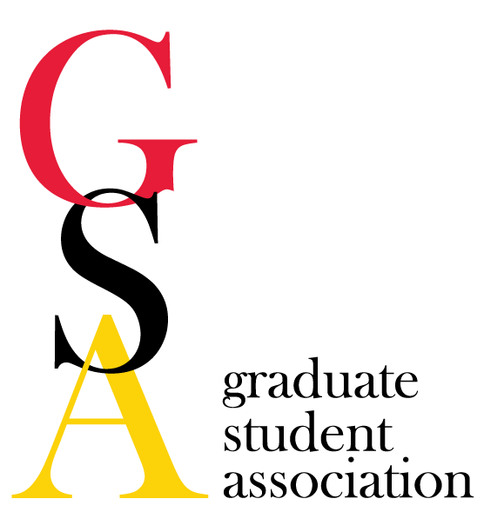
- GSA Meeting Agenda
Date: 06/01/16
- Welcome/Call to order
  - Called to order at 5:05pm by C. Chandler
  - Representatives in attendance
Morgan Bunting Danielle Abraham Kimberly Filcek
Ramon Martinez Julia Peter Susannah Shissler
Amanda Labuza Janelle Geist Chieh-ling Yang
Sarah Rudzinskas Quinton Banks Bilal Khokar
Devin Snyder Courtney Chandler Lain Hostelley
Susan Klumpner Laura Bozzi
- Review minutes of previous meeting
  - Motion to approve minutes: J. Peter
  - Second: R. Martinez
- Reports
  - President C. Chandler
    - Announcements
      - Collaborative Teaching Fellows Program
        - Summer informational meeting at JHU on June 9th
        - All graduate students welcome
        - Teaching opportunities at different schools in Baltimore Area
        - Must be able to travel to campus
      - UMB-UMBC Partnership Symposium
    - Meet & Confer Committee
      - Upcoming meeting, June 21, 2016
      - A. Labuza initiated discussion for ideas to bridge at the next Meet and Confer Committee meeting
        - Dental insurance
        - Parking update
        - Partnership between UMB and UMCP
      - Attendees: Amber Mueller, Courtney Chandler, Amanda Labuza, Danielle Abraham, Laura Bozzi.
      - If you have something you want brought up in this meeting, mention it at the June GSA Meeting or email umb.gsa.president@gmail.com or umb.gsa.sec@gmail.com.
    - Survey Results
  - Vice President L. Hostelley
    - Announcements: No announcements at this time
    - Social Activities Committee
      - Planning for summer social, ideas are welcome! Contact umb.gsa.vp@gmail.com or umb.gsa.sec@gmail.com.
    - USGA Announcements
      - No announcements, USGA on break for summer
  - Treasurer D. Snyder
    - Account
      - Total: $9335.96
      - Waiting on reimbursement from USGA ($1000.00) for Halal on the Lawn and Cyndi Rice ($540.00) for. St. Patrick’s Day Event
      - Also, waiting to hear report of results from SNAC Bubble Ball for funding purposes
    - Finance Committee
    - Awards: No travel awards at this time
  - Secretary E. Dixon
    - Announcements
      - Please contact umb.gsa.sec@gmail.com if you are not receiving emails or information about GSA Meetings.
      - Goad to improve communication in the upcoming year, any suggestions welcomed!
    - Professional Development Committee
    - GRC

  - Grad Council rep M. Bunting
    - Announcements: No announcements at this time
    - U of M grad council
  - PR
    - Announcements
      - The next edition of the Grad Gazette is planned for August. Please contact umb.gsa.pro@gmail.com or umb.gsa.sec@gmail.com with ideas or summer articles.
    - Communications Committee
  - Meyerhoff : No announcements
  - NOVA A. Labuza
    - Working on reimbursements from Halal on the Lawn
      - Remainder of donations that could not go to Spring Grove were donated to House of Ruth. Remainder of donations will be used throughout the year.
    - NOVA was given $525.00 for the year.
      - $420.00 allocated to Spring Grove Bingo for Snacks, but point person will not provide receipts at this time so money remains in the GSA account.
      - Remaining money will be used for supplies for Port Discovery in July (date to be determined).
      - Other summer event includes a movie night (“Concussion”) with discussion by faculty on TBI.
- Old Business:
- New Business:
  - Changes to the GSA meeting forum to start in the new semester. Please fill out survey to improve how meetings are run in the new year. (We appreciate all the feedback we can get!)
- Upcoming Events
  - Graduate School Orientation, August 17-18, 2016.
    - Schedule to be determined for Crab Feast and Camden Social
    - Need to coordinate with departmental orientation scheduling
    - Summer meeting will be focused on planning for orientation
- Other Business/Announcements
  - Concerns about website, needs to be updated both for the graduate school and GSA.
    - GSA website is hoped to be updated by August.
    - Reported freeze on changes to website in order to overturn information for new format.
  - UMB MSSA to host Iftars on Tuesdays and Thursdays during the month of Ramadan. UMB MSSA collecting donations for event. Please go to https://www.gofundme.com/umbmssa-iftars or https://www.facebook.com/umarylandmssa/ for more information.

Date of next meeting: July 27, 2016 in SMC Campus Center, Room 351
Proposal to move summer (July/August) meeting to July 27, 2016.
C. Chandler motions to move Summer meeting to July 27, 2916.
Seconded by S. Rudzinskas
Motion to adjourn meeting by C. Chandler.
Seconded by J. Peter
Meeting adjourned at 5:30pm.

