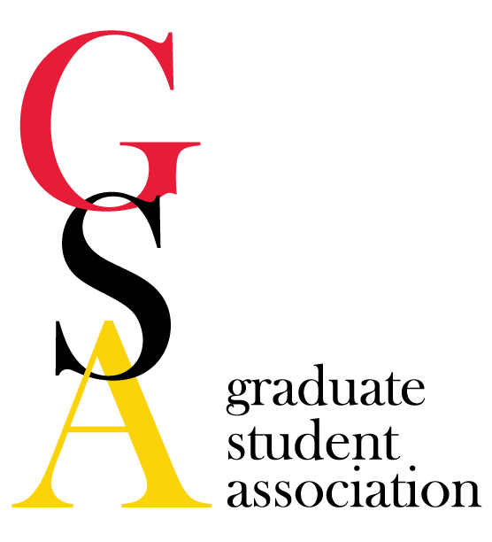
- GSA Meeting Agenda
Date: April 4, 2018

- Welcome/Call to order at 5:05 PM
Amanda Labuza Kimberly Filcek Emily Smith Ashley Marquardt
Chrissy Carney Sarah Holmes Brian Johnson Linda Senbanjo
Devin Snyder Eryn Dixon Quinton Banks Jackline Lasola
Ramon Martinez Katie Gwilliam Megan Lynch Alyssa Grogan
Courtney Chandler Susannah Shissler Janelle Hauserman Megan Moorer
Rachel Larson Allison Klein Ebehiremen Ayewoh Lauren McCarthy
Erica George Basant Motawi
- Review minutes of previous meeting - Motion A. Labuza, R. Martinez
- Reports
  - President
    - Announcements
    - Meet & Confer Committee - GSA members meet with Grad School Admin staff to talk about student needs and issues
      - Attendees: Dr. Jay Perman (UMB President), Dr. Bruce Jarrell (Executive Vice President, Provost, Dean of the Graduate School), Dr. Roger Ward (Senior Vice President for Operations & Institutional Effectiveness and Vice Dean of the Graduate School), and Dr. Erin Golembewski (Senior Associate Dean of the Graduate School); Courtney Chandler (GSA President), Megan Lynch (GSA GC Rep), Ramon Martinez (Pharm. Sci.), Amanda Labuza (Neuro).
      - Graduate Assistant Timekeeping - “in the future” (this has been status quo for about two years now; they will let us know when things change)
      - Support for Puerto Rican students displaced by the hurricanes - Dr. Ward talked to the Provost at PR University; they said they were okay with university accommodations and student relocations. UMB has offered their support to students in need through formal channels.
      - Centennial Celebration - planning something for the fall.
      - HB-199 (“Collective Bargaining Rights”) - if this bill passes, communications between graduate students and the administration would have to occur through formal (union-mediated) channels; that means we would have to end the GAAC meetings. If the bill passes, we would have to decide if the GAAC meetings are enough. Dr. Perman said that in terms of response to the bill, UMB would follow the lead of the Board of Regents. Also pointed out that unionization would occur across the system, which would be more of a “one size fits all” approach. UMB’s graduate environment is a bit unique.
      - Changes to the graduate student handbook - Courtney sent her suggested changes to Dr. Golembewski. They agreed that time off should be secured for graduate students and will work on making the changes for next year.
      - Gun Safety Policy on campus - we asked what it was; guns are NOT allowed anywhere on campus or in any campus buildings (this is Maryland law); our policy is shaped by the Maryland System policy; when you’re off campus, state law kicks in.
        - The UMB police put on Active Shooter Training. Currently it hasn’t been offered to students. We asked for it to be offered to students in some capacity (for example, online tutorial at the minimum). They are going to look in to this possibility.
  - Vice President
    - Announcements - none
    - Social Activities Committee
    - USGA Announcements
  - Treasurer
    - Account
      - Current Balance: $16,425.99
      - We spent $2780.44 on the GRC/Candidacy Ceremony
        - Under budget on Catering and Supplies
        - Alcohol: $770.00 from sponsors
    - Finance Committee: Travel Awards
      - Applications Due: April 15th
        - Make sure the application is complete - including receipts and signatures
        - Make sure applicants know to email Susannah the application
    - Student Group Funding
      - Balance: $676.39 left for student groups
      - Reminder that all receipts are due within one month of the date on the receipt
  - Secretary
    - Announcements
    - Thanks to everyone who volunteered to make the GRC successful this year! Making some adjustments for next year, so it is even better.
  - Grad Council rep
    - Announcements
      - Outstanding mentor award applications due April 20th
    - U of M grad council - meeting tomorrow April 5th
    - Professional Development Committee
      - For Oct -March opportunities, due April 27
  - PR
    - Announcements:
      - Next gazette will be April 6th - this Friday!
      - Volunteer Event - Community Engagement Center, event May 5th
        - Three different shifts (9-11 AM set up, 10:30 AM-1:00 PM festival help, 12:30-3:00 PM clean up)
        - Sign up to volunteer!!
    - Communications Committee
    - Volunteer Committee
  - Meyerhoff - No updates
  - NOVA
    - Brain awareness week - over 90 students attended
    - Halal on the lawn - April 20!
      - Bring toiletries, male clothing, books, etc. for free food :)
- Old Business:
  - Health insurance - no concrete updates. Was told by the administration that they don’t currently expect any dramatic changes. They are currently analyzing the utilization from last year. We should know about any changes by the end of April.
  - HB-199 (“Collective Bargaining Rights”) - no progress since the last meeting; still sitting with the House Appropriations Committee; SB560 (cross-reference for the Senate version of the bill) is sitting with the Senate Finance Committee
- New Business:
  - Toastmasters funding request & budget presentation - requesting $160 for two events ($95 for Interview 101 Event, $65 for Open House)
    - Goal: Make good leaders and communicators through an international organization
    - Offering hands on training for public speaking skills through planned and impromptu speeches
    - Interview 101 - April 25th in SMC or Pharmacy Hall
    - Open House - April 24th in SMC
    - Fully funded for $160: Stipulations - Send out through two GSA list serves, Jenn Aumiller, and Gazette, Attendance breakdown including PhD/Masters
  - E-board nominations for next year! We will vote at the May meeting. People can self-nominate or nominate someone else. All nominees must accept the nomination (an email to umb.gsa.president.com will suffice). Nominations will be accepted up until the position is voted upon during the May meeting. Current nominations are listed below:
    - President - Megan Lynch (accepted)
    - Vice President - Ramon Martinez (accepted)
    - Treasurer - Susannah (accepted)
    - Secretary - Alyssa Grogan (accepted)
    - Public Relations Officer - Katie Gwilliam (accepted)
    - Grad Council Rep - Janelle Hauserman (accepted)
- Upcoming Events:
  - Halal on the Lawn - Friday, April 20th!
  - PGSA Coffee House - April 20th! Come showcase our talents!
  - Travel Awards: Due April 15th
  - Outstanding Mentor Award: Due April 20th
  - Toastmaster Open House: April 24th
  - Toastmaster Interview 101: April 25th
  - Professional Development Award: Opening on April 16th, closing on April 27th
  - Hooding Ceremony - Thursday, May 17th
    - Need ~10 volunteers!
- Other Business/Announcements

Date of next meeting: May 2, 2018

Motion to adjourn: L. Senbanjo, Q. Banks

