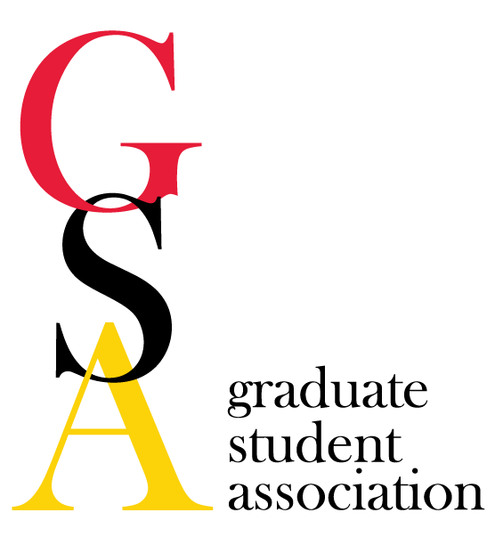

GSA Meeting Minutes
Date: May 7th, 2014

- The meeting was called to order at 5:04pm. 5/6 exec. committee members in attendance plus 12 reps (representing 10 programs and 2 Supported Groups):
  - G. Heinzl (PSC, Pr.)
  - J. Vandigo (PHSR, VP)
  - G. Jones (MMIC, Meyerhoff, Tres)
  - R. Johnson (GERO, GC)
  - K. Gilpin (PIN, PR)
  - S. Rudzinskas (PIN)
  - J. VanRyzin (PIN)
  - D. Bollino (MMED)
  - B. Garzel (PSC)
  - A. Mueller (MMED)
  - C. Gaines (MBIC)
  - C. Ross (MBIC)
  - A. Labuza (PIN, NOVA)
  - K. Edwards (TOX)
  - K. Kim (SOWK)
  - A. Reinhart (MMIC)
  - L. Bozzi (HGEN)

- Review minutes of previous meeting: Error in 04.02.14 minutes (NOVA finding) - Edited A. Reinhart motioned to accept edited minutes; 2nd by A. Mueller

- Reports
  - President: Title IX training must be completed online.
  - Vice President: USGA held the end of the year social at Camden Pub. New USGA executive board members elected
  - Pres: Spencer Todd, Parliamentarian: Geoffrey Heinzl
  - Treasurer: We have ~$10,000. Our next concern is financing orientation events.
  - Grad Council Rep: Had final meeting May 1st; UMBC is awarding >100 PhDs this spring, UMB - 37; UMD GSA hosted elections; propose online degree audit website for students to check for themselves. Next meeting is in September.
  - PR: Spring Circulator edition went out; potential summer edition pending next PR rep.
  - NOVA: Hosted Halal on the nursing school lawn, >80 people, lots of donations; Speaker Box purchased; plan to elect officers next meeting.
  - Meyerhoff: Dr. Harold Varmus' talk was a great success; Cedric Uytingco spoke at Brown University. Hosted annual Meyerhoff dinner at the Masonic Grand Lodge attended by two members of congress, several military generals, foreign dignitaries, UMBC President Freeman Hrabowski, UMSOM Dean E. Albert Reece, and Mr. Robert Meyerhoff himself.

- Old Business—
  - Committee Reports
    - Finance: awarded 6 TAs; July15th is next deadline
    - M&C: agenda to bring issues to Dr. Perman at meeting on Monday - health insurance, HS-HSL library hours
    - Social Activities: no new updates
    - Professional Development: met and discussed Dr. Patricia Sokolove Outstanding Mentor Award
    - Dirt: project put on hold due to legalities concerning university liability

- New Business
  - Sokolove Award: To outstanding mentor at the Hooding. PD committee chose Dr. Onukwugha from Pharmaceutical Health Services Research- she will speak at Hooding Ceremony.
  - Hooding Ceremony on May 15th, 6 volunteers should be available until 3pm: N. Perry, G. Heinzl, C. Ross, L. Croft, H. Anderson, A. Labuza, S. Rudzinskas. Snacks provided outside upon completion of ceremony.
  - E-board 2014-2015 Nominations:
VP: J. VanRyzin nominated by L. Bozzi, A. Reinhart 2nd
C. Ross nominated by G. Heinzl, J. Vandigo 2nd
Tres: A. Reinhart nominated by S. Rudzinskas, J. Vandigo 2nd
Sec: A. Mueller nominated by J. Vandigo, G. Heinzl 2nd
GCP: C. Gaines nominated by R. Johnson, A. Reinhart 2nd
PR: K. Edwards nominated by G. Heinzl, A. Mueller 2nd
- All nominees accepted their nomination - Elections will be held at June meeting.
- Upcoming Events: K. Edwards suggests organizing/participation in a Fall Community Service Fair to promote science to youth.

- Other business/Announcements

G. Heinzl motioned to adjourn meeting, A. Reinhart 2nd. Meeting adjourned at 6:05 pm.

- Date of next meeting: June 4th, 2014.

